Specializations

1. Specializations

1.1 INTRODUCTION


1.2 BUYERS
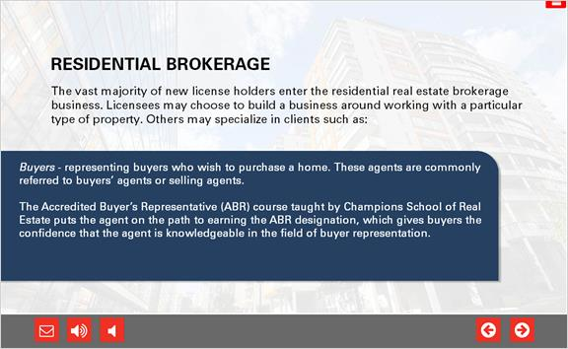

1.3 SELLERS
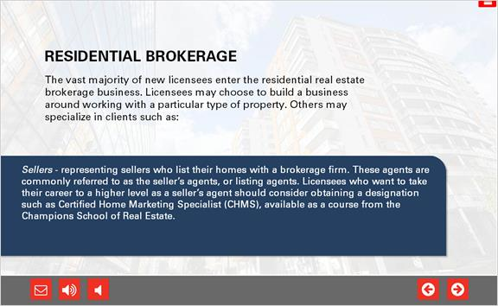

1.4 RELOCATION AND RESORTS
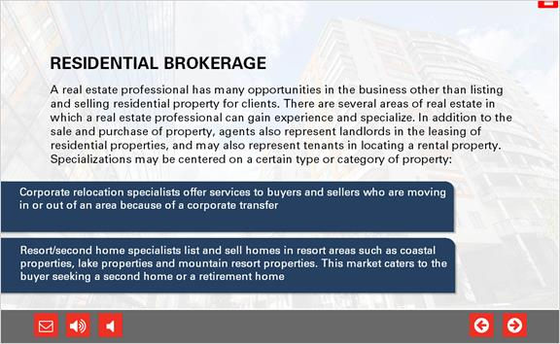

1.5 MULTI-FAMILY
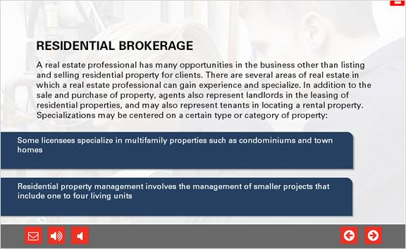

1.6 FARM AND RANCH
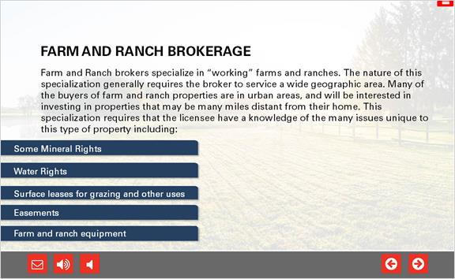

1.7 FARM AND RANCH
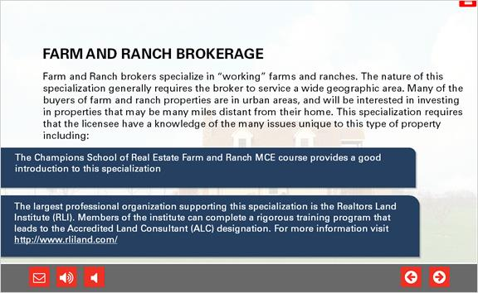

1.8 COMMERCIAL
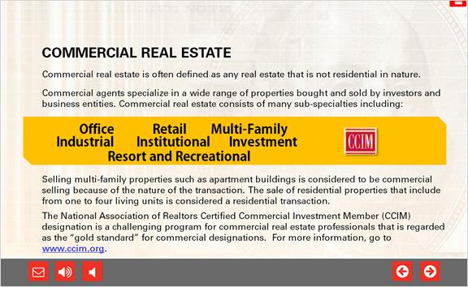

1.9 LAND BROKERAGE
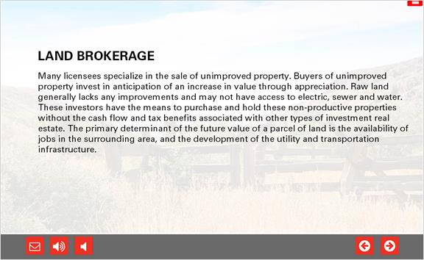

1.10 INVESTMENT
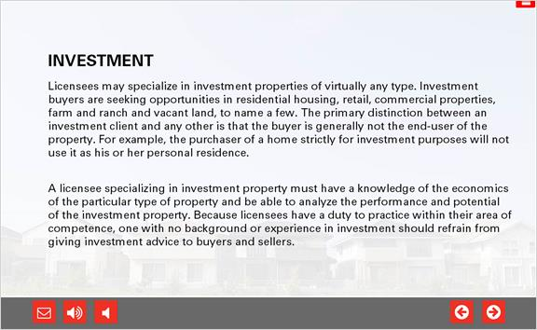

1.11 LEASING
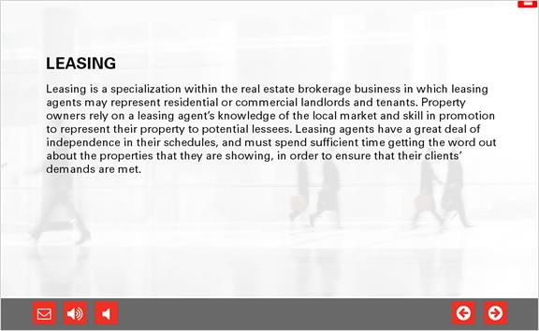

1.12 REO
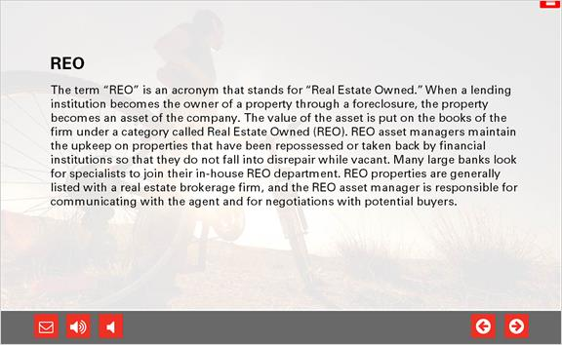

1.13 FORECLOSURE
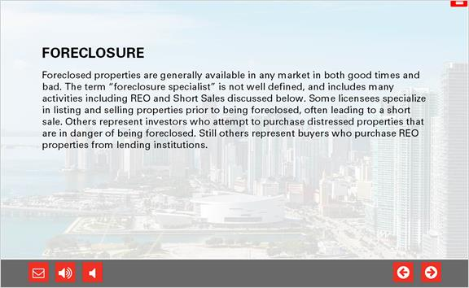

1.14 SHORT SALE
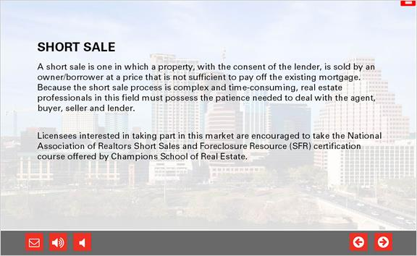

1.15 AUCTION
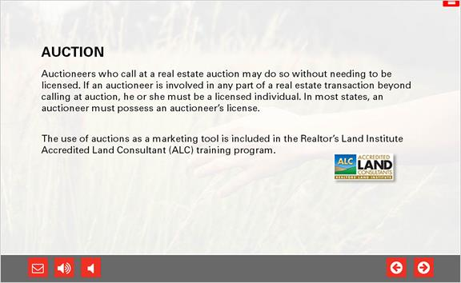

1.16 RESORT
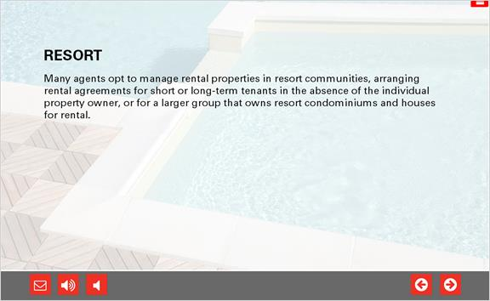

1.17 HOME INSPECTION
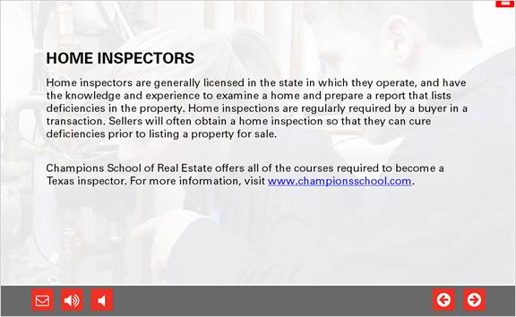

1.18 REAL ESTATE DEVELOPMENT
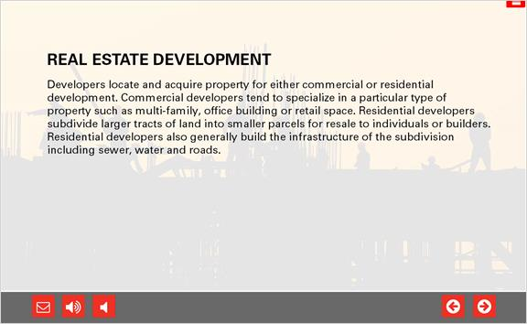

1.19 PROPERTY MANAGEMENT
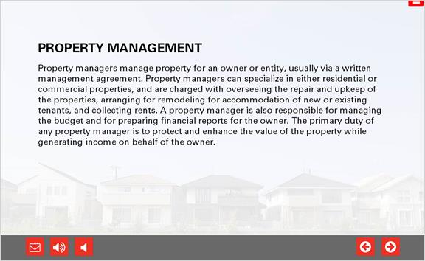

1.20 FINANCE
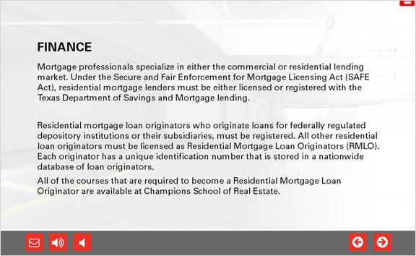

1.21 APPRAISAL
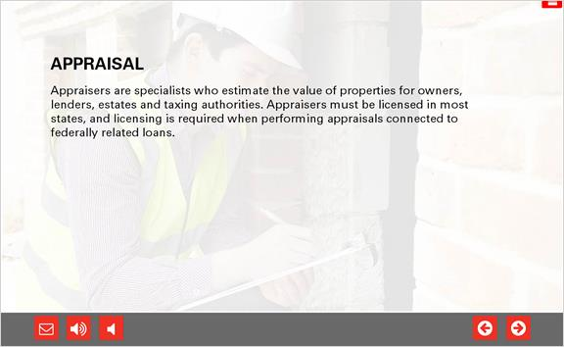

1.22 BROKER'S RESPONSIBILITY
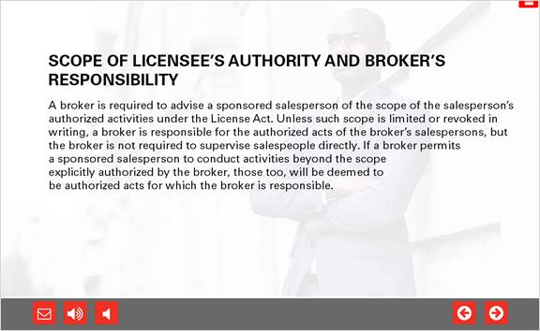

1.23 LICENSE HOLDER'S RESPONSIBILITY
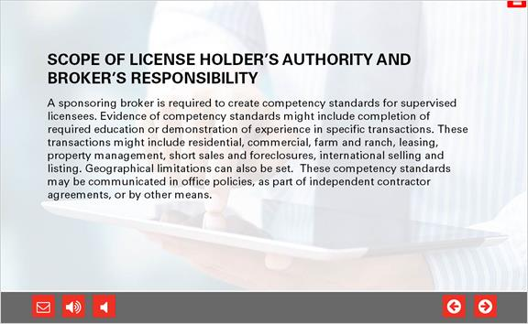

1.24 COMPETENCY CONSIDERATIONS
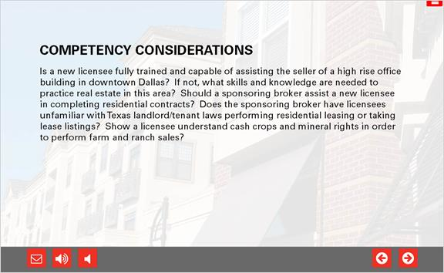

1.25 POLICIES
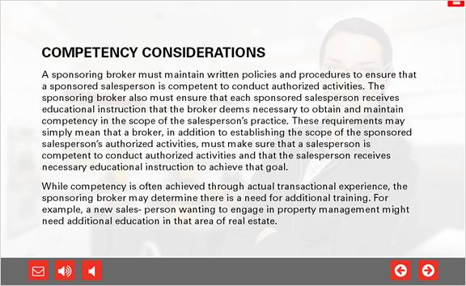

1.26 BACKGROUND CHECKS
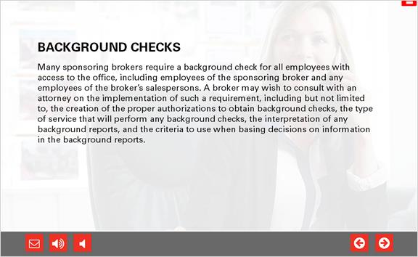

1.27 Specializations Quiz
(Multiple Choice, 10 points, 1 attempt permitted)
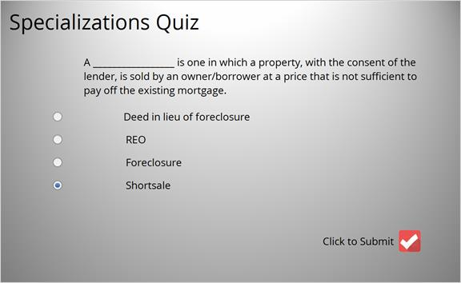
Correct | Choice
 | Deed in lieu of foreclosure
 | REO
 | Foreclosure
X | Shortsale
Feedback when correct:
That's right! You selected the correct response.
Feedback when incorrect:
You did not select the correct response.

Correct (Slide Layer)
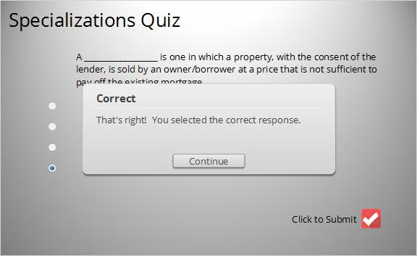

Incorrect (Slide Layer)
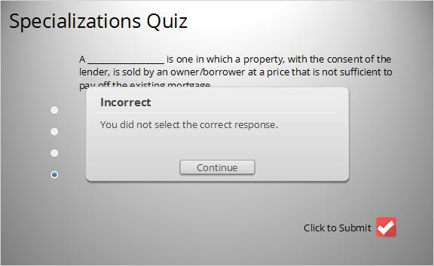

Review (Slide Layer)
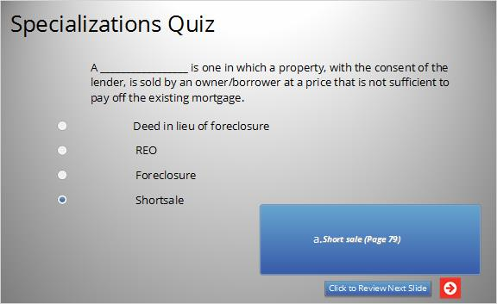

1.28 Specializations Quiz
(Multiple Choice, 10 points, 1 attempt permitted)
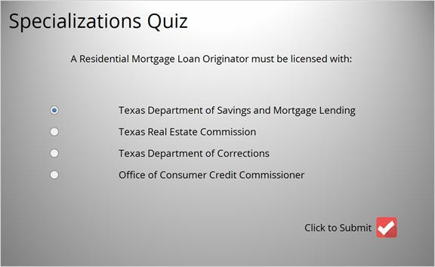
Correct | Choice
X | Texas Department of Savings and Mortgage Lending
 | Texas Real Estate Commission
 | Texas Department of Corrections
 | Office of Consumer Credit Commissioner

Feedback when correct:
That's right! You selected the correct response.
Feedback when incorrect:
You did not select the correct response.

Correct (Slide Layer)
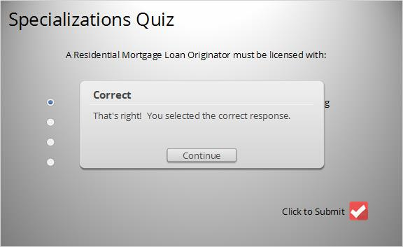

Incorrect (Slide Layer)
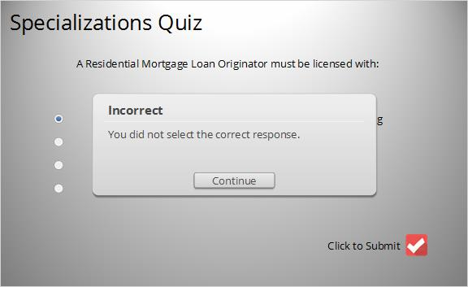

Review (Slide Layer)
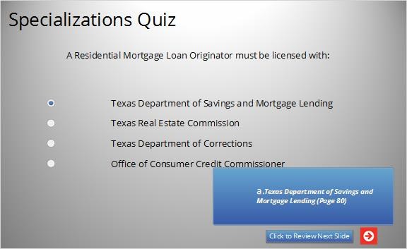

1.29 Specializations Quiz
(Multiple Choice, 10 points, 1 attempt permitted)
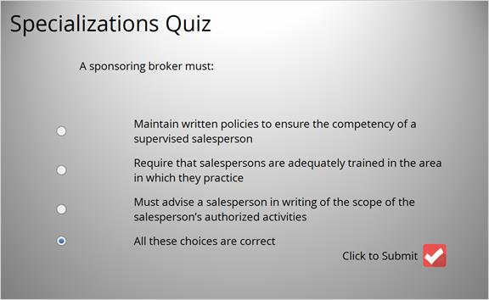
Correct | Choice
Maintain written policies to ensure the competency of a
supervised salesperson
Require that salespersons are adequately trained in the area
in which they practice
Must advise a salesperson in writing of the scope of the
salesperson’s authorized activities
X | All these choices are correct

Feedback when correct:
That's right! You selected the correct response.
Feedback when incorrect:
You did not select the correct response.

Correct (Slide Layer)
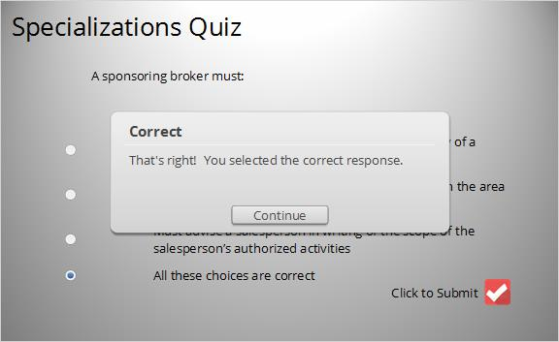

Incorrect (Slide Layer)
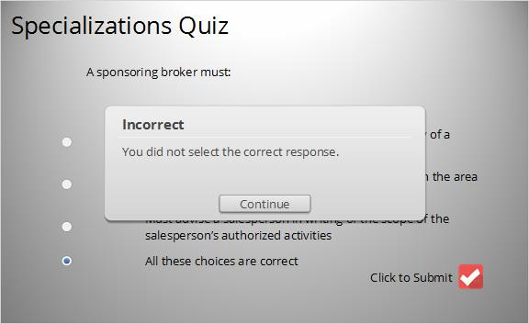

Review (Slide Layer)
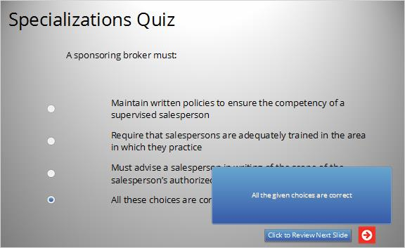

1.30 Specializations Quiz
(Multiple Choice, 10 points, 1 attempt permitted)
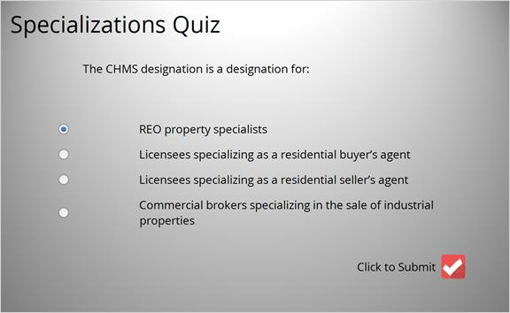
Correct | Choice
X | REO property specialists
 | Licensees specializing as a residential buyer’s agent
 | Licensees specializing as a residential seller’s agent
Commercial brokers specializing in the sale of industrial
properties

Feedback when correct:
That's right! You selected the correct response.
Feedback when incorrect:
You did not select the correct response.

Correct (Slide Layer)
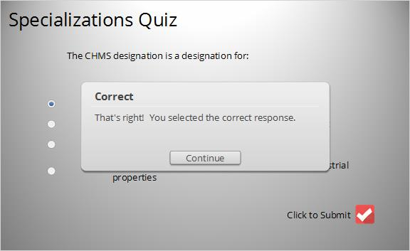

Incorrect (Slide Layer)
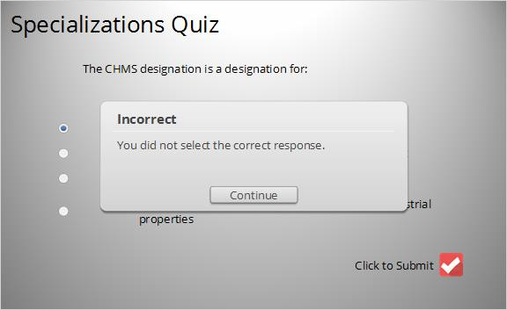

Review (Slide Layer)
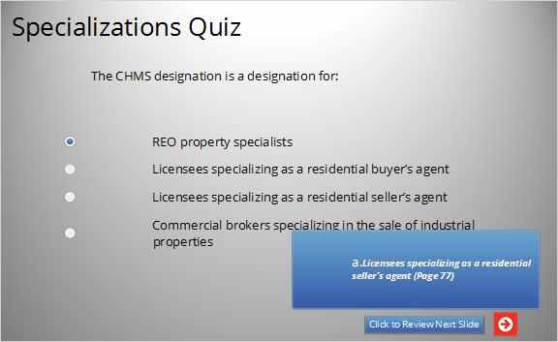

1.31 Results Slide
(Results Slide, 0 points, 1 attempt permitted)
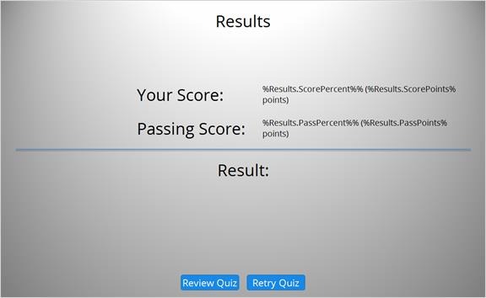

Results for
1.27 Specializations Quiz
1.28 Specializations Quiz
1.29 Specializations Quiz
1.30 Specializations Quiz

Result slide properties
Passing Score | 70%

Success (Slide Layer)
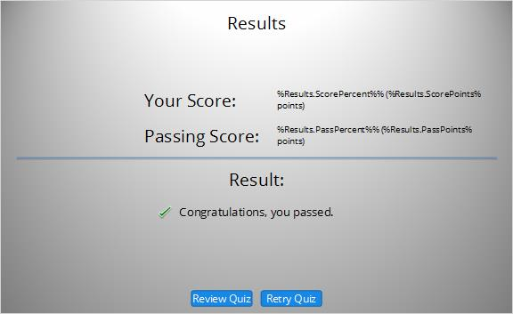

Failure (Slide Layer)
